

**FEDERAL REPUBLIC OF NIGERIA**

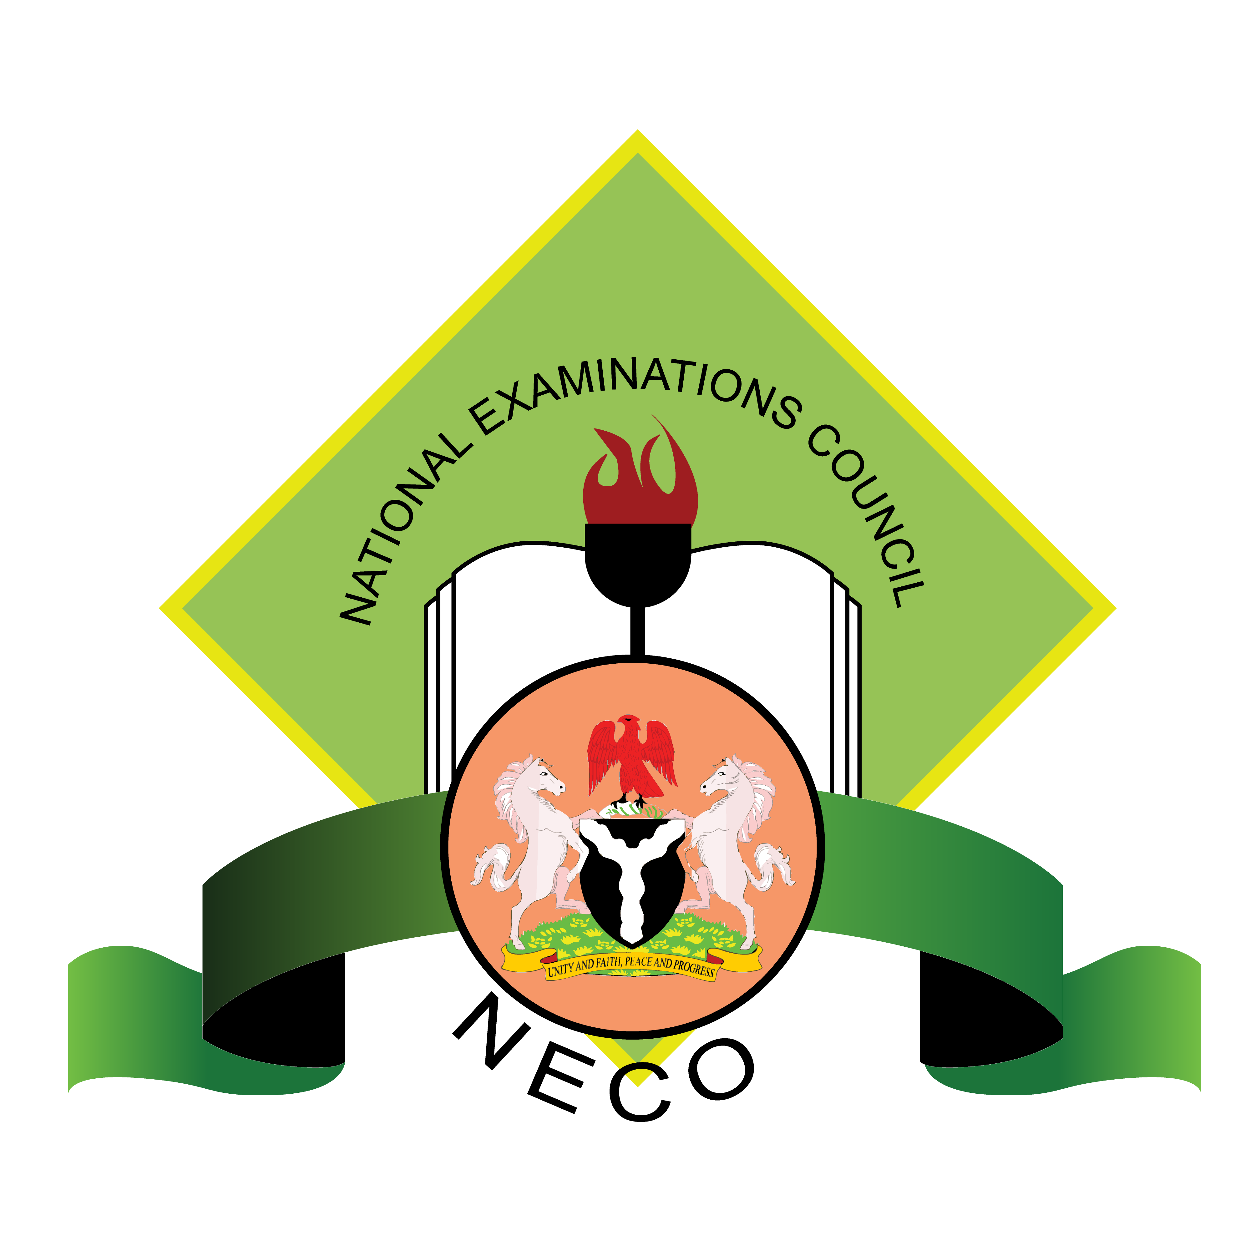

**NATIONAL EXAMINATIONS COUNCIL**

**SENIOR SCHOOL CERTIFICATE EXAMINATION (SSCE) RESULT**

JUN/JUL

2020

**AGBOWO**

**IZUCHUKWU**

**JOHN-KEN**

**2002-06-02**

*Candidate Name*

*Date of Birth*

**20126583**

**DF**

**2020**

**SSCE_INT**

*Registration Number*

*Exam Year*

*Exam Type*

**0200425**

**S -TEE HIGH SCHOOL, FESTAC TOWN, LAGOS**

*Centre Number*

*Center Name*

**S/N**

**SUBJECT**

**GRADE**

**REMARK**

1

English Language

**C5**

CREDIT

2

Mathematics

**C5**

CREDIT

3

Civic Education

**C5**

CREDIT

4

Computer Studies

**B3**

GOOD

5

Government

**C6**

CREDIT

6

Economics

**\***

PENDING

7

Financial Accounting

**D7**

PASS

8

Commerce

**\***

PENDING

9

Salesmanship

**C5**

CREDIT

©

2021

National Examinations Council (NECO)

